WHY HARVEST?

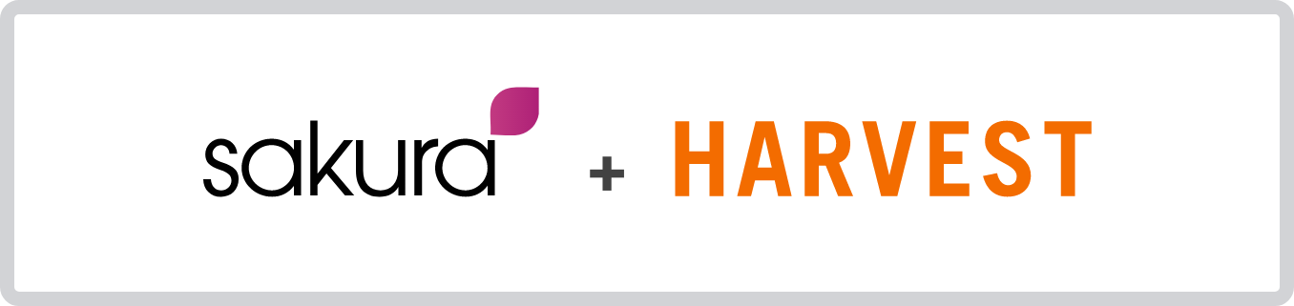

Who are they?

1
US based time and timesheet recording and team scheduling software developer e.g. Harvest and Forecast, but which is used extensively by SMEs extensively across the UK, US and more widely.

Software functionality

2
Harvest enables businesses to track and record staff time either on a ‘real time’ (using timers) or a daily/weekly timesheet basis for clients, projects and individual tasks etc. It also allows for budgets and capacity to be set for individuals and on specific projects, as well as identifying both billable and non billable time. Harvest also contains powerful and flexible reporting on all team recorded time.

Separately Harvest enables business expenses to be tracked and recorded as well as automatically enabling billable time to be converted into sales invoices to
be forwarded to customers.

Software options and pricing

3
Harvest is priced for a minimum of two Users for businesses with unlimited access
e.g. $25.00 per month. Thereafter unlimited additional staff can be added to the business account at $12.00 per month per User.

Mobile app

4
Harvest also includes a mobile app, enabling most of the functionality to be accesses offsite when necessary e.g. recording time in the normal way, reviewing reports etc.

Integration opportunities

5
Harvest integrates key data with a variety of other accountancy and payment software, including Xero, Quickbooks, Stripe and PAYPal. It also integrates with it’s associated team scheduling software, Forecast.

Passionate about your business

