ACTIONS THAT IMPACT THE BUSINESS
- VAT
This is an opportunity to impact business cashflow in a positive way fairly immediately.
This payment deferral applies to all VAT registered businesses in the UK i.e. if you have a VAT return for the quarters to 29th February 2020 / 31st March 2020 and 30th April 2020 with payments dates due by 7 April / by 7 May and by 7 June i.e. NO payment is required to HMRC through to June 2020.
However you need to ensure that the VAT returns are prepared and submitted on time but cancel any direct debit immediately that may already be in place.
One of the team from Sakura will contact you to remind you to do this, if not this week then early next week !
ACTION REQUIRED – NONE, AUTOMATICALLY APPLIED

- HMRC ‘Time to Pay’
There is also an opportunity to impact business cashflow in respect of other HMRC liabilities that may be due and payable during this period e.g. Corporation tax or PAYE/NI liabilities that are due and payable.
HMRC has a set up a special phone helpline 0800 0159 559/0800 024 1222 to support businesses where they are concerned about not being able to pay their tax in full due to the impact of coronavirus (COVID-19).
Typically HMRC will agree a longer timeframe of monthly payments to resolve the outstanding tax liability with the taxpayer.
ACTION REQUIRED – CONTACT HMRC

- Business Rates Holiday 2020/21

Where your business is in the retail, hospitality or leisure sector and currently pays business rates, the recent Government announcements mean you will have an immediate cashflow benefit from April 2020 onwards.
All (occupied) retail, hospitality and leisure businesses in England, are entitled to the business rates holiday, where they are wholly or mainly used as :
- shops, restaurants, cafes, drinking establishments, cinemas and live music venues
- for assembly and leisure
- for hospitality, as hotels, guest & boarding premises or self-catering accommodation
Local authorities may have to reissue your annual rate bill in due course.
ACTION REQUIRED – NONE, AUTOMATICALLY APPLIED

- Protection from Eviction (for Commercial Tenants)
Commercial tenants who cannot pay their rent because of COVID-19 will be protected from eviction.
These measures will mean no business will automatically forfeit their lease and be forced out of their premises, if they miss a payment up until 30 June 2020 (which may be extended if necessary)
ACTION REQUIRED – COMMUNICATE WITH YOUR LANDLORD

- Business Grants (Retail and Hospitality Grant Scheme)
Where you have a business that is in the retail, hospitality or leisure sector and currently pays business rates, there are also some business grants available of up to £25,000, to help cover any immediate cash-flow problems.
All (occupied) retail, hospitality and leisure businesses in England, will be entitled to access these grants, where they are wholly or mainly used as :
- shops, restaurants, cafes, drinking establishments, cinemas and live music venues
- for assembly and leisure
- for hospitality, as hotels, guest & boarding premises or self-catering accommodation
Businesses in these sectors with a property that has a rateable value of up to £15,000 may be eligible for a grant of £10,000, whereas businesses which are operating from a property with a rateable value between £15,000 to £51,000, are able to apply for grants of up to £25,000.
ACTION REQUIRED – NONE, YOUR LOCAL AUTHORITY WILL CONTACT YOU
- Business Grants (Small Business Grant Scheme)
Separately the very smallest businesses, who may not currently pay business rates (under the Small Business Rates Relief (SBRR) and Rural Rates Reliefs), are able to apply for a grant of up to £10,000, with the aim of helping such businesses to meet their ongoing business costs.
Small businesses that are based in England and occupying a property, but receiving small business rate relief or rural rate relief at 11 March 2020 will be entitled to access this grant.
ACTION REQUIRED – NONE, YOUR LOCAL AUTHORITY WILL CONTACT YOU

- COVID-19 Statutory Sick Pay
For all businesses with less than 250 employees, the cost of providing 2 weeks of COVID-19 related statutory sick pay per employee will be refunded by the government in full.
This is a useful cashflow benefit in terms of funds that will offset staff salary costs that have already been incurred, but may not be received until mid/late April 2020. It will be at an amount of £94.25 SSP per day for up to 14 days per employee affected.

The amount of the SSP reimbursement will be based from the first day of COVID-19 related absence and will apply retrospectively from 13 March 2020.
There is no system in place with HMRC to enable a reimbursement to be made to Employers for SSP, however my view is that it is likely to be managed through the normal payroll software or HMRC online services, so the Sakura team should be able to manage this on your behalf.
ACTION REQUIRED – UNCLEAR, BUT NOTIFY US WITH ANY COVID-19 ABSENCES
- Coronavirus Business Interruption Loan Scheme (CBILS)
The most significant finance support for businesses experiencing the impact of the COVID-19 situation, is probably the Coronavirus Business Interruption Loan Scheme (CBILS).
In particular it has been highlighted as a means for businesses (and Employers) to obtain short term funding to assist with cashflow problems ahead of the implementation of the Coronavirus Job Retention Scheme (CJRS) !
The scheme was launched in the week commencing 23 March 2020 and is expected to be available for 6 months.
It is being overseen by the British Business Bank, but the funding is being delivered in practice to businesses by the main banks and other UK lenders i.e. high-street banks, challenger banks, asset-based lenders, smaller specialist local lenders etc.
More than 40 lenders including the big four banks are part of the scheme (see below)
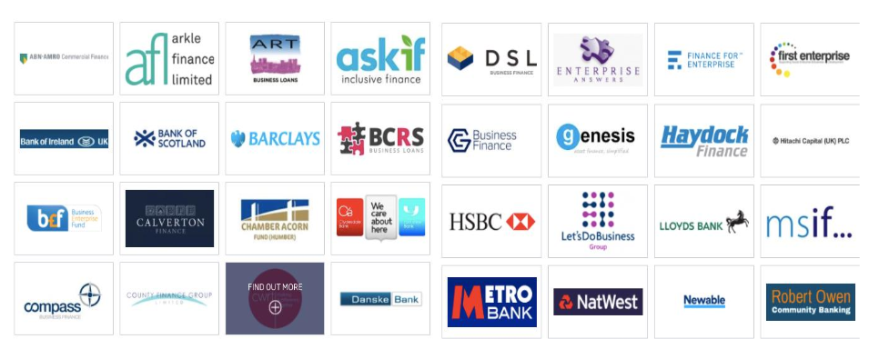
The main forms of finance being offered by the banks/lenders through the CBILS scheme appear to be mainly term loans and overdrafts (although asset and invoice finance can be provided to businesses under the scheme as well).

Feedback received to date on access to the CBILS scheme via the banks etc, suggests the following:
- that it is proving difficult to make contact with local business managers or the relevant departments in the banks/lenders e.g. they are struggling to meet demand from businesses (telephone lines are constantly busy)
- that even on websites and online platforms, the level of demand is resulting in the websites ‘crashing’ or ‘timing out’
- many banks/lenders are prioritising applications under the CBILS scheme to existing customers
- the list of detailed eligibility requirements are not wholly clear under the scheme yet, and/or eligibility for businesses are being interpreted or applied differently by different banks/lenders
- all of the ‘normal’ credit requirements and information under standard lending, appear to being applied equally under the CBILS scheme i.e. NO ‘fast track’ approach is being taken to CBILS applications at present (even with the 80% guarantee from the Government available to banks/lenders).

Therefore, my suggestion is that in the short term,
- if the requirement is not immediately urgent, it may be sensible to consider an application later in the 6 month period of the scheme, and
- perhaps consider using an overdraft facility rather than a term loan, as these can be applied for online with your bank/lender immediately in some instances
[PLEASE NOTE - There is an existing finance provider to early stage businesses (under the British Business Bank), BUT which is NOT part of the CBILS scheme (at present) i.e. for early stage businesses in their first two years of trading, the British Business Bank’s Start Up Loans programme (loans £500 to £25,000 at 6% p.a. interest) may be more suitable. Visit www.startuploans.co.uk for more information]
At Sakura we are available to assist or support you with any loan applications you may make under the CBILS scheme, whether with providing copies of financial information, cashflow/expense modelling etc., so please feel free to contact us.
ACTION REQUIRED – CONTACT YOUR BANK AND/OR APPLY ONLINE (IF URGENT)
- Coronavirus (COVID-19) Job Retention Scheme (CJRS)
The other significant announcement of financial support for businesses was the introduction of the Coronavirus Job Retention Scheme CJRS), a scheme set up for UK Employers to obtain reimbursement of part of their employees’ salary, for those employees that would otherwise have been laid off (or made redundant) during this COVID-19 situation.
Under the scheme, HMRC will reimburse 80% of ‘furloughed workers’ ‘wage costs’, up to a maximum per employee of £2,500 per month. Additionally the scheme has been backdated to 1st March 2020 and is initially for a period of 3 month only (although it can be extended where necessary).
The ‘furlough’ process is a new term (and process) and therefore Employers may need to seek legal or HR advice to ensure that employee contractual or other rights are not negatively impacted, and/or decisions made now, don’t result in employment tribunal issues at a later date !

Broadly, Employers should discuss with their staff and make any changes to the employment contract by agreement, and to be eligible for the CJRS scheme, employers should have written confirmation of the ‘furloughing’ of each employee.
We expect that once the online portal for the CJRS scheme becomes available towards the end of April 2020, then the team at Sakura will be able to obtain the required information, from each Employer in respect of all ‘furloughed’ employees, as part of our normal payroll processes.
We should then be in a position to prepare the calculation of the amount to be reimbursed under the scheme, and hopefully make the claim on your behalf with HMRC.
ACTION REQUIRED – CONTACT SAKURA WITH ‘FURLOUGH’ EMPLOYEES, DATES ETC.

ACTIONS THAT IMPACT DIRECTORS (PERSONALLY) AND EMPLOYEES
- Self Assessment Income Tax Payments
For individuals who pay under the Income Tax Self-Assessment regime, the main cashflow benefit from the Government is that the payment on account due on the 31 July 2020, may now be deferred until 31 January 2021.
It is applicable to all Self assessment individuals i.e. you are eligible if you are due to pay your second self-assessment payment on account (POA) on 31 July 2020, and do not need to be self-employed to avail of the deferment.
ACTION REQUIRED – NONE, AUTOMATICALLY AVAILABLE

- Protection from Eviction (Residential Tenants)
Residential tenants who are experiencing financial difficulties because of COVID-19, will be protected from eviction by the Government for a period of 3 months (which may be extended, if necessary)
ACTION REQUIRED – COMMUNICATE WITH YOUR LANDLORD

- Mortgage Repayment Holiday
Government have agreed with UK mortgage lenders to provide support to customers that are experiencing issues with their finances as a result of the measures taken around COVID -19.
This is mainly though providing payment holidays of up to 3 months to individuals, thereby allowing them the necessary time to recover their personal finances in the meantime.
The precise criteria required by each lender is currently unclear, however in many cases it appears it can be applied for online.
ACTION REQUIRED – APPLY FOR THE ‘PAYMENT HOLIDAY’ VIA YOUR MORTGAGE PROVIDER

- ‘Buy to Let’ Landlord Holiday
Government have also agreed with UK mortgage lenders to provide support to landlords of ‘buy to let’ property, that are experiencing issues where the landlord’s tenants are experiencing financial difficulties because of COVID-19 situation.
Similarly as above, a 3 month payment holiday can be applied for with the mortgage lender, BUT with the quid pro quo that landlords will not be able to start proceedings to evict tenants for at least a 3 month period.
ACTION REQUIRED – APPLY FOR THE ‘PAYMENT HOLIDAY’ VIA YOUR MORTGAGE PROVIDER
- DWP Universal Credit
Employees that have been ‘furloughed’ or made redundant may be able to make a claim for the loss or reduction in their salary through the Universal Credit system
ACTION REQUIRED – CONTACT THE DWP

